Order Workflow GUI Design

Speedy Snacks - March 22, 2023

# Introduction

It's essential to account for the various statuses an order may have when integrating with multiple food delivery APIs like Uber Eats, DoorDash, and Skip the Dishes. While each platform may use slightly different terminologies and enum values, you can expect to handle the following order statuses:

1. Pending: The order has been placed but not yet accepted by the restaurant.
2. Accepted: The restaurant has accepted the order and started preparing the food.
3. In Preparation: The order is being prepared by the restaurant.
4. Ready for Pickup: The order is ready and waiting for the delivery driver to pick it up.
5. (Completed) Picked Up: The delivery driver has picked up the order from the restaurant.
6. In Transit: The order is en route to the customer.
7. Delivered: The order has been delivered to the customer.
8. Cancelled: The order has been cancelled by either the customer, the restaurant, or the delivery platform.
9. Rejected: The restaurant has rejected the order.
10. Error: There was an issue with the order (e.g., payment or technical problem).

# State Diagram

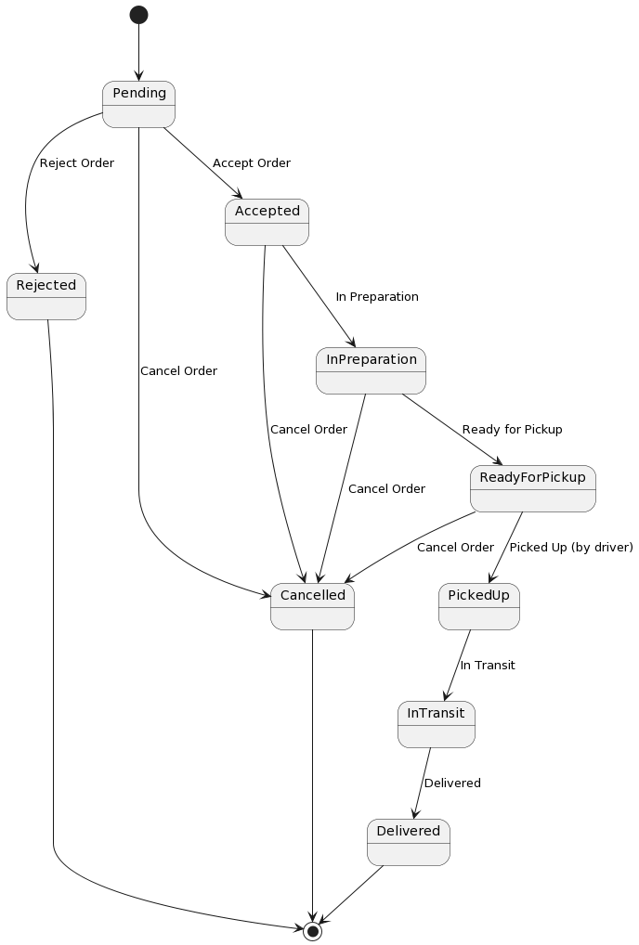

# Pending

When an order is in Pending status, the fulfillment partner should have a limited set of actions they can take to change the order status. These two buttons should be available:

"Accept Order": This button allows the fulfillment partner to change the order status from Pending to Accepted. When they accept the order, they acknowledge that they have received it and will start preparing the food.

"Reject Order": This button allows the fulfillment partner to reject the order, changing the status to Rejected (and adding it to the table of Cancelled orders in MySQL). The restaurant may need to reject an order for various reasons, such as running out of an item or being unable to handle the order at that time.

Ensure that the other buttons, such as "Ready for Pickup," "Picked Up," "In Transit," and "Delivered," are not available when the order is in Pending status, as these actions are not appropriate for this stage in the order process.

# Accepted

When an order is in the Accepted status, these buttons should be available:

"In Preparation": This button allows the fulfillment partner to update the order status from Accepted to In Preparation, indicating that the restaurant has started preparing the food.

"Ready for Pickup": This button allows the fulfillment partner to change the order status from Accepted to Ready for Pickup, signaling that the food is ready and waiting for the delivery driver to pick it up.

"Cancel Order": This button allows the fulfillment partner to cancel the order, changing the status to Cancelled. Although less common at this stage, there may still be exceptional circumstances where the restaurant needs to cancel the order.

# In Preparation

When an order is in the In Preparation status, these buttons should be available:

"Ready for Pickup": This button allows the fulfillment partner to change the order status from "In Preparation" to "Ready for Pickup," indicating that the food is prepared and waiting for the delivery driver to pick it up.

"Cancel Order": This button allows the fulfillment partner to cancel the order, changing the status to "Cancelled." While it's less common to cancel an order at this stage, there may be exceptional circumstances where the restaurant needs to cancel the order, such as discovering an issue with the prepared food.

# Ready for Pickup

When an order is in the "Ready for Pickup" status, the fulfillment partner (restaurant) typically has fewer actions available, as the responsibility shifts to the delivery driver.

"Cancel Order": This button allows the fulfillment partner to cancel the order, changing the status to "Cancelled." Although quite rare at this stage, there may be exceptional circumstances where the restaurant needs to cancel the order, such as realizing a mistake in the order or an issue with the prepared food.

# Completed

When an order is in one of the following statuses, the fulfillment partner (restaurant) generally has no direct actions available to change the order status, as the responsibility has shifted to the delivery driver:

* Picked Up
* In Transit
* Delivered

At this stage, the order is already en route to the customer, and the restaurant's involvement in the process is minimal. **On the Speedy Snacks end, all of these statuses will be grouped under the status Completed.**

# Delivery App Support Information

It may be desirable to include a button at any stage in the workflow that provides a static page with contact information for the delivery apps. In the event we decide to create a "Contact Delivery App Support" button, the support contact information is provided below.

Uber Eats:

Restaurants can access support directly through the Uber Eats app or the Uber Eats Manager (https://restaurant.uber.com). There, they can find help articles, chat support, or contact the support team. For more general inquiries or information, the Uber Eats Help Center is available at <https://help.uber.com/ubereats>.

DoorDash:

Restaurant partners can access support through the DoorDash Merchant Portal (https://merchant.doordash.com). There, they can find help articles, chat support, or contact the support team. Alternatively, DoorDash support can be reached by phone at +1 (855) 973-1040.

Skip the Dishes:

Restaurant partners can access support by logging into their Restaurant Partner account at https://partner.skipthedishes.com and visiting the Help section. For urgent matters, restaurant partners can call the Skip the Dishes support line at +1 (866) 328-6144 (Canadian partners) or +1 (855) 200-7547 (US partners).